1. Details of program:

Inputs are some of the #define values

N is array x/y values

J and I are the x and y values

**Important method functions**

**Check Neighbor:**

This will check to see if the tour is completed and closed

I set up the ability to print in the comments, as well as limit the number of prints.

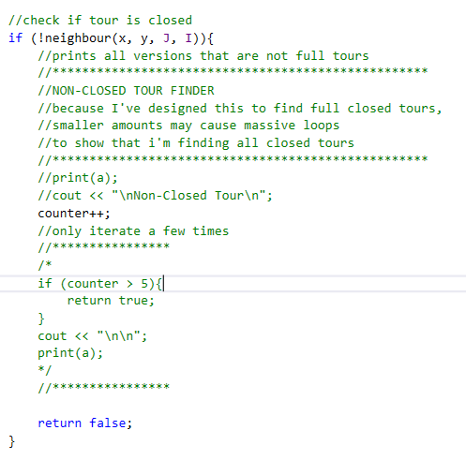

**Knights Movements:**

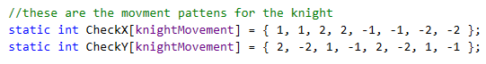

**Find Degrees:**

Find the degrees of the surrounding areas that are empty

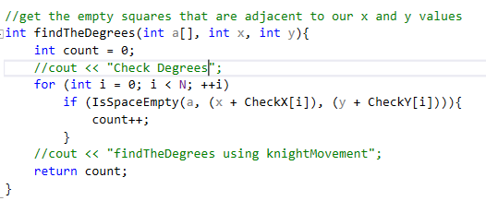

**Check The Next Move:**

Basic idea: check movements of the knight, get the minimum degrees and return back to the method to our other methods to try to find a solution.

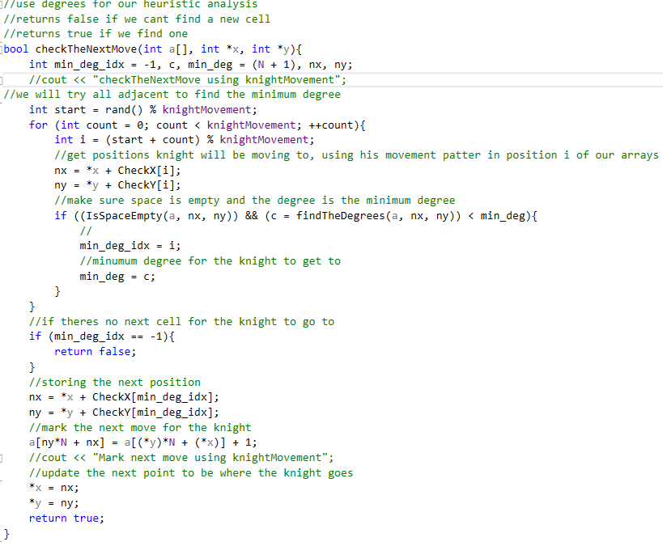

1. Tested, my program can't seem to find any complete circuits, but it can find out how to occupy every space at one interval.
2. My program seems to get stuck in a loop trying to make a complete route for this 5x5 group, I left it running for over an hour, and it didn't find a solution. So this tells me that a complete route is impossible for this N size.

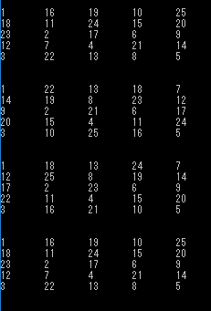

1. My program is made to find closed tours, It took 12 non-complete tours to find a complete one. I’ve attached results from four runs the total number of tours from the first run was:

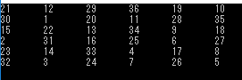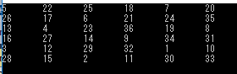

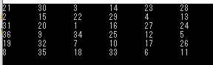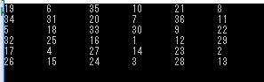

1. My program is made to find closed tours, It took 4 non-complete tours to find a complete one. I’ve attached results from four runs the total number of tours from the first run was:

